3.1 District Wise Crimes against women

3.2 Highest number of Rapes & Kidnappings

3.3 – Lowest Number of Rapes & Kidnappings

3.4 – insert records for District Crime ST data

3.5

3.6 – Lowest Murder

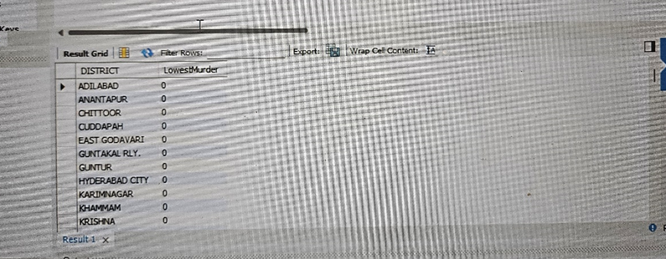

3.7 Murders in Ascending Order

3.8.1 – Insert data IPC

3.8.2 – Highest Number of Murders yearwise

